Valley Striders Junior Survey September 2016
Q1. Which is the preferred location for VS training sessions?
Graph to show the favourite location of VS junior training sessions.
In this question, “Which location do you prefer?”, 58.33% of juniors preferred training at Leos Rugby Club, rather than GSAL. Perhaps sessions should be more frequently at Leos.
Q2. How much is the Eccup Mile enjoyed?
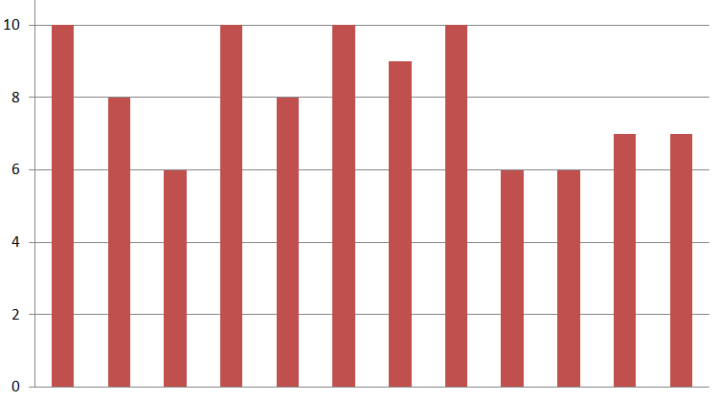
Graph to show an example of answers given for the 1 to 10 rating of the Eccup Mile
In a question asking participants to rate the Eccup mile from 1 to 10, we had great feedback, with an average rating of just over 8(8.083), and many giving 10s, the low point was only 6. We also had very positive comments, which will be down at the bottom with all the replies from the comment box.
Q3. Favourite activities
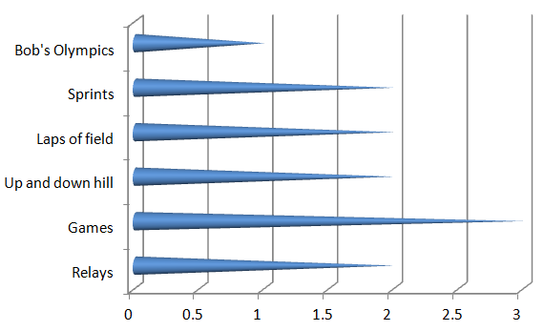Graph to show favourite activity during training sessions
Unfortunately, this question was left out by some of the participants, but out of the replies we did get, the most ratings was given to games, but with a close balance, only one vote ahead of the other activities, excluding Bob’s Olympics.
Q4. Food At Leos
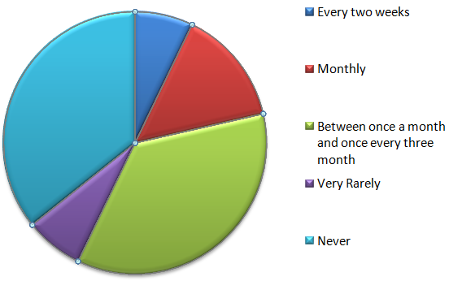Graph to show frequency of juniors eating food after VS training sessions
Question four asked how often the participant ate food at Leos Rugby Club, and the joint most popular answers were “between once a month and once every three months” and “never”. Possibly the food should be advertised a bit more, because many people I saw filling in the surveys didn’t know that you could eat after training sessions. Unsurprisingly the “between once a month and once every three months” had many votes because of its large amount of time.
Q5. Track sessions at Leeds Grammar School

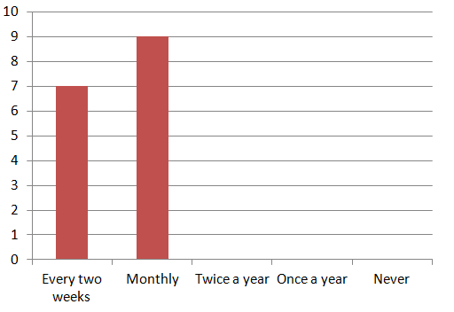Graph to show the demanded frequency of VS training sessions on the track
Question five asked how often participants wanted to train on the track at Leeds Grammar School. This was very popular, as all of the juniors wanted to attend the track sessions either once a month or every two weeks! The most popular was the monthly option though, and it may be difficult trying to get a slot at GSAL every two weeks. This would also mean with the Eccup Mile, we would only be able to fit in one session every month at Leo’s in the summer.
Q6. Long jump at GSAL 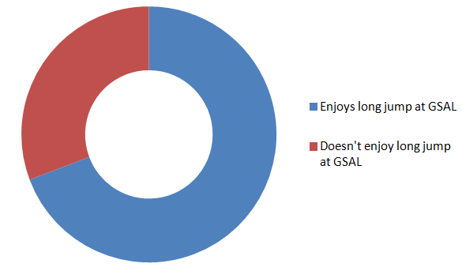
Graph to show amount of people wanting to do long jump during track sessions
In this question, “When we train at the Grammar School, would you enjoy just concentrating on running, or would you like to include a third of the session doing long jump?” it showed that less than three quarters of juniors(69%) wanted to work on their field abilities, and wanted to carry on running. Possibly there should be an option of skipping the long jump section for those that don’t enjoy it next summer.
Q7. Running outside of Valley Striders
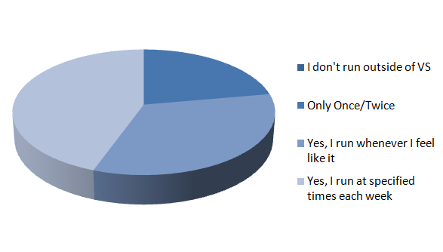Graph to show if VS juniors train outside of Valley Striders training sessions

The seventh question of the survey asked how often the participant runs outside of Valley Strider’s Junior training sessions, excluding races (Parkruns etc). Surprisingly, nobody ticked the box confessing to not running outside of VS club nights, while results showed that one third of Valley Striders juniors ran whenever they felt like it, as well as 44.4% of them sticking to a training plan and running at specified times each week. 2 ninths of runners train, but quite infrequently.
Q8.Frequency of juniors competing in races/junior parkruns
Graph to show the number of times VS runners get involved in races or parkruns

Question eight was asked to discover how often Valley Striders is represented in races or parkruns. Amazingly, everyone out of the participants has raced before! Also, nearly 75% (73.3%) of them compete every week! Two fifteenths of people race monthly and one out of fifteen people race infrequently and 6.6% have competed once or twice.

Q9.Valley Striders Colours
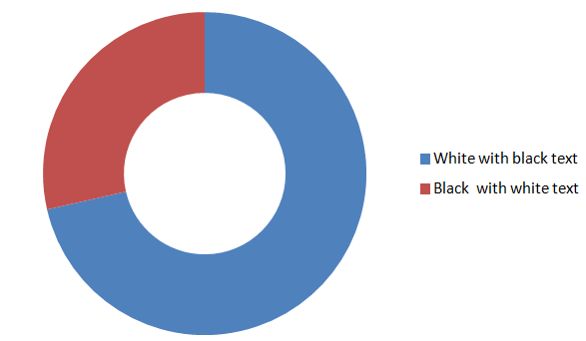Graph to show which colour scheme participants prefer
Recently, there has been a few people trying to change the Valley Striders colours to black with white text over the current white with black text, and wearing those colours at races. But as this graph shows, the large majority of people would rather keep the traditional white colour, with over 70% (71.4%) of participants, preferring the traditional white colour scheme. Also, it would be incredibly difficult for us to invert the colour scheme, as everyone one would need new kit, new flag, changes to the website etc.
10. Extra comment section
Question ten asked if there was anything the participant could be done to improve the club, or any extra comments they would like to share, here is some examples.
“It would be better if we did more long distance running at our own speed.”
“Leave the Rugby Club!”
“I would enjoy more track sessions.”
“It would be better if I did more running distances at my own pace.”
“I would like to do longer runs and train more than once a week.”
“Stop letting the people who mess about do whatever they want without punishment.”
“Train more than once a week!”
“I would like to train at Roundhay.”
“It would be a lot better with less messing around.”
“I like it all!”
“My daughter loved the Eccup Mile and never stops talking about it.”
“Do you do any training at the weekends? If not racing?”
“I would prefer black with white text. My mum would also prefer black with withe text as she is dreadfully pale!”
“I would love it if there were sweets at the end of training sessions.”
“Train more than once a week.”
“It would be great if we trained at different places e.g. Roundhay.”
“We need to change the colours.”
“Everybody needs to stop messing around.”
“I’d like it if they include different tops like the crop top.”
“I want to do more road sessions”
“People messing around are ruining the training sessions.”
“We should train more for cross countries.”

